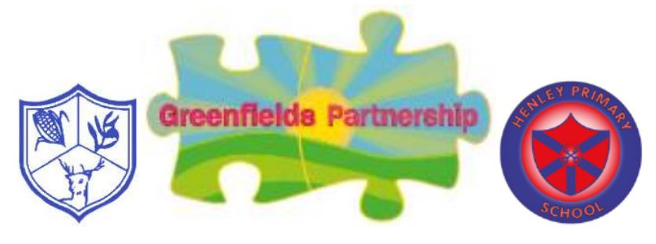

Criteria for Supporting Reading at Greenfields
One to One Reading
Teachers rarely have the time to listen to children reading individually. However, if they did, the teacher could choose a book closely matched to the GPCs (Grapheme-Phoneme Correspondence) the child knew, and the number of words the child would be likely to be able to read ‘at a glance’.
The teacher would start by showing interest in the book, connecting it to something the child knew about or had read before. The teacher would expect the child to sound out unfamiliar words and would praise them for doing so.
The teacher might re-read a sentence or a page to the child to help them keep track of what was going on and explain the meaning of a word in the context of the story. Sometimes they might re-read sections together.
At the end of the reading, the teacher might say, ‘You could read this to your dad tonight. He’ll be so impressed’.
Above all, the teacher would make the process interactive and meaningful. The next day, they might start a new book together or re-read the same book so the child could read more words ‘at a glance’ and notice more of what they were reading.
The Reading Framework (2021) Section 3 p23

Before Reading Occurs
- Discuss the title and make predictions about the book.
Examples of questions:
What do you notice about the cover?
What type of genre do you think the book is?
How does reading a fiction book differ to a non-fiction book?
For older children reading larger books, allow time to recap on what they have already read, asking open-ended questions to assess their understanding.
- Look through the book – many books for younger readers have the sounds listed on the front, or back cover, for which phoneme knowledge the children will need to decode. Revisit these with the child.
- Also common exception words (CEW) are sometimes highlighted – point these out, practise reading and discuss the tricky parts.

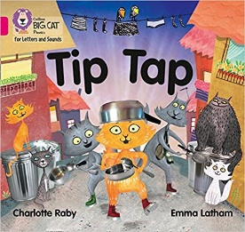

During Reading
- Children point to the words/phonemes in the book - to continue to finger track or use a book mark to keep the place when reading.
- Children always say the word once they’ve sounded it out e.g. ch-air - ‘chair’. Then go back and re-read the whole sentence to support fluency.
- Correct children’s schwa when they are sounding out each phoneme, e.g. for ‘der’ keep the sound pure ‘dddd’ children to practise.
- Phonics is the main strategy used to decode words. Other strategies can be discussed e.g. using the picture clues to help or context of the sentence.
- CEW – These are introduced alongside the phonics programme – children cannot decode these words. The adult will tell them the word and discuss the tricky part e.g. in ‘was’ the ‘a’ is making an ‘o’ sound.

During Reading… continued
- Unknown phoneme – if a child cannot remember the phoneme, refer back to the phoneme mat for support to link with the picture and the action. Practise reading that phoneme in the word. Adult to support the sounding out of that word - counting the phonemes, dotting and dashing the word. We use dots and dashes to show which letters make the sounds. We use a dot if one letter makes one sound e.g. d. If a sound is made up of two or more letters, we use a dash underneath, e.g. igh. If there is a spilt digraph, where another letter is in the middle, we use a line to connect the two letters that are split.

- Encourage expression when reading. Adult will model this e.g. “Look there is an ! We read this sentence like this…” (demonstrate it). Discuss - Why do you think we do this and add expression? Which way sounded better? Does this change the meaning?
- Re-read sections for fluency. Adult to model using the punctuation clues and discuss the differences.
- Explain unknown vocabulary – Wait for the child to finish reading the page (unless they stop to ask for the meaning of the word). Explain the meaning of the word when the child has finished the page. E.g. I was really interested in this word that you said….do you know what it means? Then model putting it in a sentence. Can the child use it in a sentence?



At the End of the Reading Session
- If the child has struggled to read (decode the words), leave the comprehension questions until the end of the book. This will reduce the cognitive load. Use the book to find the answers – the adult can re-read the passage and the child identifies the answer.
- If the child can read well but struggles with comprehension, asking a simple retrieval question at the end of each page and then revisiting those questions again at the end but worded differently, can build their understanding and retain key information.
- Comprehension questions need to be targeted and specific with a variety of questions – e.g. recall, inference, prediction, summarising.

Examples of questions
Level 1 Retrieval Questioning
- What are the characters’ names?
- What objects does this text talk about?
- Where is the story taking place?
- Which character said this?
- What did they do next?

Level 2 Summarising Questioning
- What’s happening in this part of the text?
- How are these two characters different?
- What has happened to the characters in this part of the text?
- How are the pictures a good match for the words?
- How would you summarise the ending?

Level 4 Inference Questioning
- Why did the character do that?
- What caused that to happen?
- How does the writer show the character feels this way?
- Why do you feel that way about the character?
- What do you think the character would be thinking at this point in the story

Level 3 Vocabulary and Explaining Questioning
- What does this metaphor mean?
- What does this word tell us about the character?
- What have we learned about this character’s personality from this section?
- What impression do we get about this character and why?

